EOS MCP - Product page
- Connect EOS MCP: https://eos.auroraer.com/dragonfly/user-guides/eos/aurora-mcp-guide?locale=en#quick-start
- Book a demo: https://bookings.cloud.microsoft/book/CommercialWorkshopBookings@auroraer.com/s/n2uLQiae5k67LMn2_yx3Xg2?ismsaljsauthenabled
- View all: It should redirect to the 2nd page we are working on: AI-Powered Energy Workflows
- Video: Work in progress. Could we use a placeholder in the meantime?
- About the slider vs carousel – We intend it to be an animation just as shown in the html file I sent. Would you need a file for that? Please indicate dimensions and format.
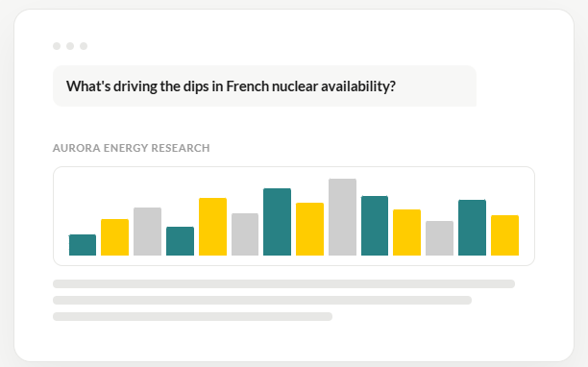
- About the accordion: It’s not expandible. I agree. Could we replace the + symbols for other ones that don’t imply it’s expandable? Whatever we are already using in the web would work.
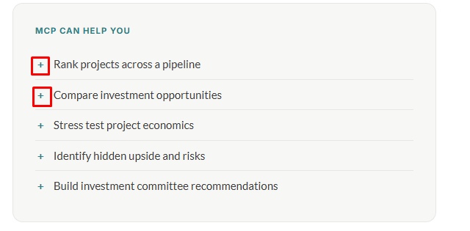
- Resources: each should redirect to a different section in the 2nd page we are working on: AI-Powered Energy Workflows.
  - Box 1: What’s an MCP – CTA: Understand MCPs
  - Box 2: See EOS MCP in action - Watch real examples
  - Box 3: Frequently asked questions - Get answers
I’m attaching images for the background
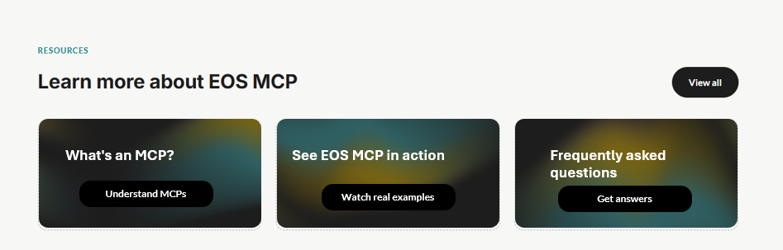

EOS MCP - Product page

- Connect EOS MCP: https://eos.auroraer.com/dragonfly/user-guides/eos/aurora-mcp-guide?locale=en#quick-start
- Book a demo: https://bookings.cloud.microsoft/book/CommercialWorkshopBookings@auroraer.com/s/n2uLQiae5k67LMn2_yx3Xg2?ismsaljsauthenabled
- Video links: They are still in progress. Could we please get placeholders in the meantime?
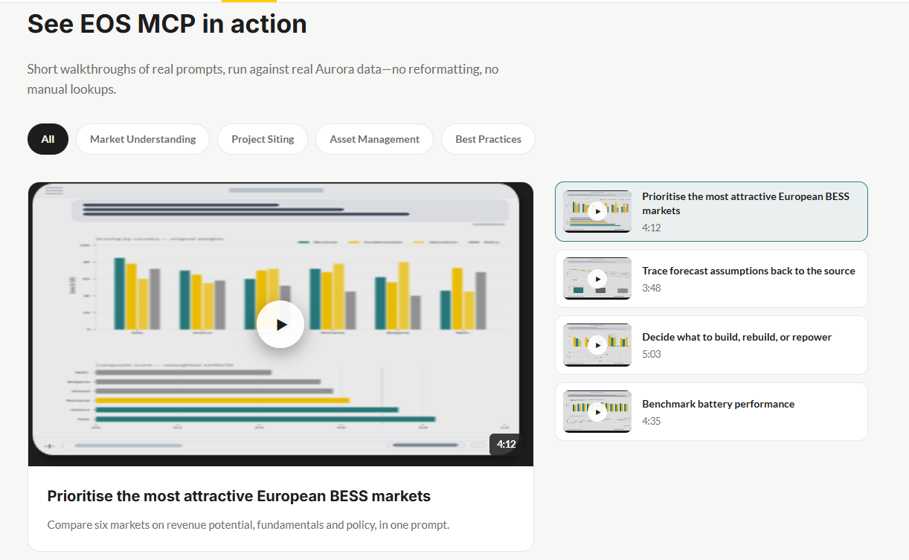
- Additional request: If it doesn’t delay delivery, could we add images to the “get started” section so it looks like this? I’m attaching the images (239 x 486 pixels each.) in the mail. Please tell me if you need anything else.
